TRICK AND TREAT HALLOWEEN MAGIC! 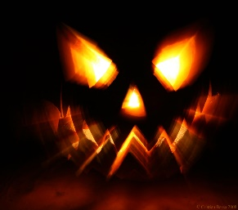
MAGIC SHOW
SPECTACULAR MAGIC SHOW SUITABLE FOR ALL AGES, PG RECOMMENDED
Featuring Magicians…
RICHARD WIBBERLEY
ELIO SIMONETTI
JOHN CAIRNS
COME JOIN THE THIS SPECTACULAR SHOW FUN OF HALLOWEEN MAGIC WITH THESE AMAZING MAGICIANS!!
DRESS IN YOUR SPOOKIEST HALLOWEEN COSTUMES – PRIZE FOR BEST DRESSED!!!
THURSDAY OCT 31^{ST @} 7PM
@ THE MAGIC ZONE THEATRE
25 MICHELLAN CRT, BAYSWATER VIC…PH: 03 97298918
www.themagiczone.com.au TICKETS…www.trybooking.com/BFSXU
$10 TICKET ENTRY…Kids under 4 free…Tea & Coffee Provided – BYO Snacks & Drinks
ALL PROCEEDS GO TO EASTERN PALLIATIVE CARE – A GREAT LOCAL CAUSE TO PROVIDE A CARING ENVIROMENT TO THE ELDERLY.

